CPISM



***Practical exam paper for HCJS - HTML5, CSS, JavaScript*** *Duration: 60 minutes | Total Marks: 15*

Create a regsiter form as the picture bellow

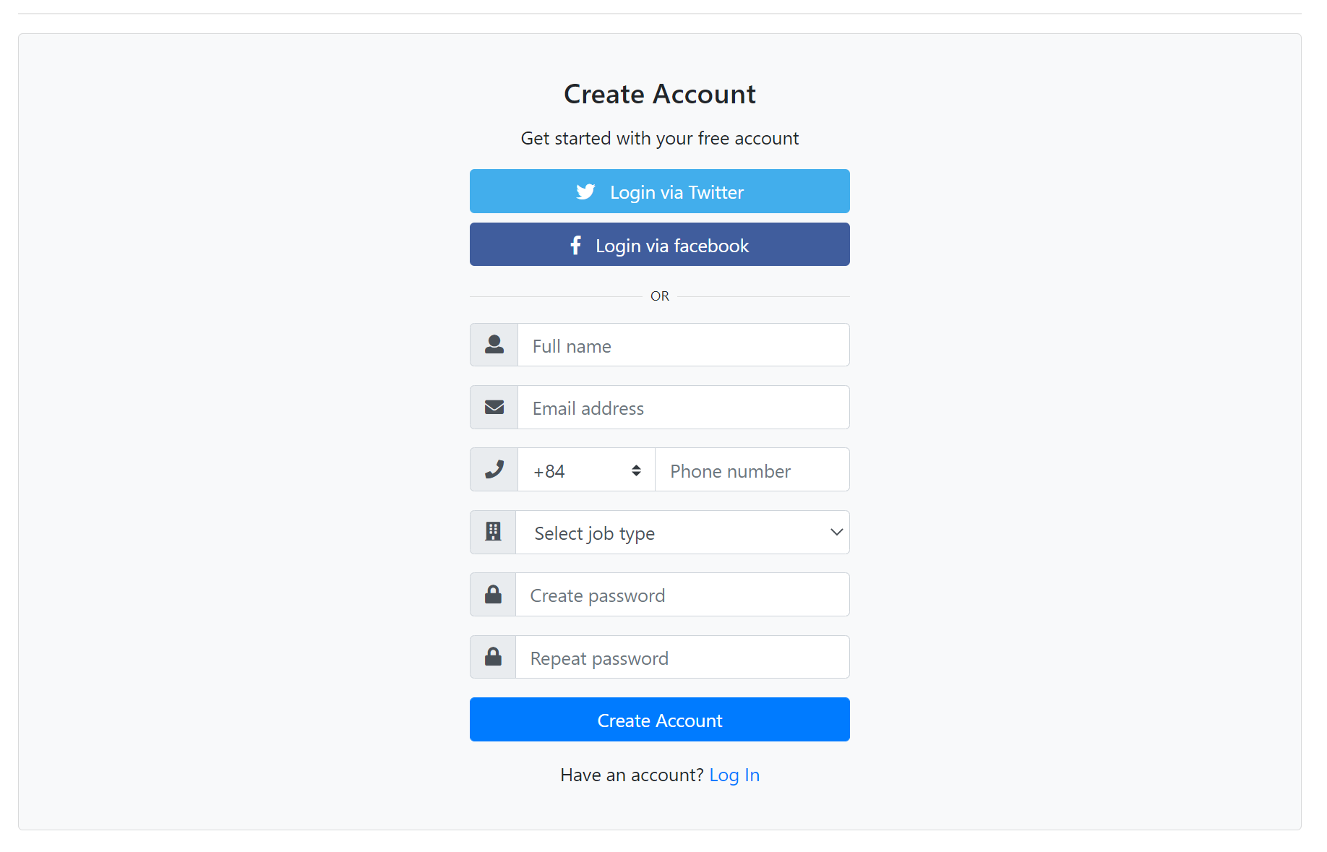

Practical Paper 1/2

***Notes:***

- You can use bootstrap or jquery to create website

- You can use fonticon as Glyphicon or Fontawesome

- Form must be validated

- Select job type:

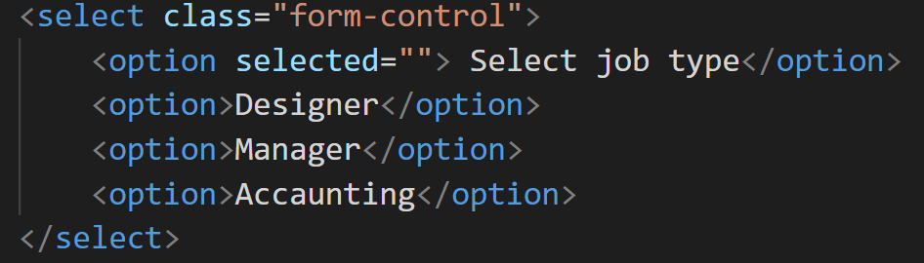

| **Marking:** | |
| --- | --- |
| **Exercise 1:** | |
| 12.0 | Create form Register |
| 8.0 | Validating data input |
| 5.0 | Use font icon |
| ***25.0*** | ***Total Marks*** |

Practical Paper 2/2